Pierce County
General Farming Private Applicator Training Class

Tuesday March 19th – 8:30 a.m. – 3:00 p.m.
Annex Conf. Room – PC Courthouse, Ellsworth
Come in the west side of the courthouse by the Holiday gas station.

Purchase a book a week or more prior to class. Books can be purchased at any Extension Office for $40 -
General Farming – Private Category 101/101
Eighth Edition
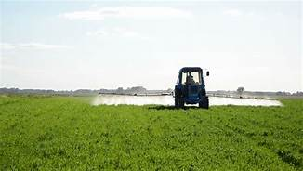
Ag Educator – Mike Travis
715-273-6781

Other courses in our area:
- Thursday Feb. 21st – Pepin County 715-672-5214

- Wednesday Feb. 27th – Polk County 715-485-8600

